SIMATS ENGINEERING ASSESSMENT TOOL 2

NAME: Gurram Roshitha
REG NO: 192373027
COURSE NAME : Internet Programming
COURSE CODE: CSA4303

C03-AT2

1. Servlet Architecture & Workflow Question:
Present the architecture of Java Servlets and explain the complete request–response cycle with a neat diagram.
Focus Areas:
- Client–Server interaction
- Role of Web Container
- Request and Response objects

Answer:
Java Servlets – Complete Solutions
1. Servlet Architecture & Workflow

Definition
A Java Servlet is a server-side Java program used to handle client requests and generate dynamic responses.

Servlet Architecture
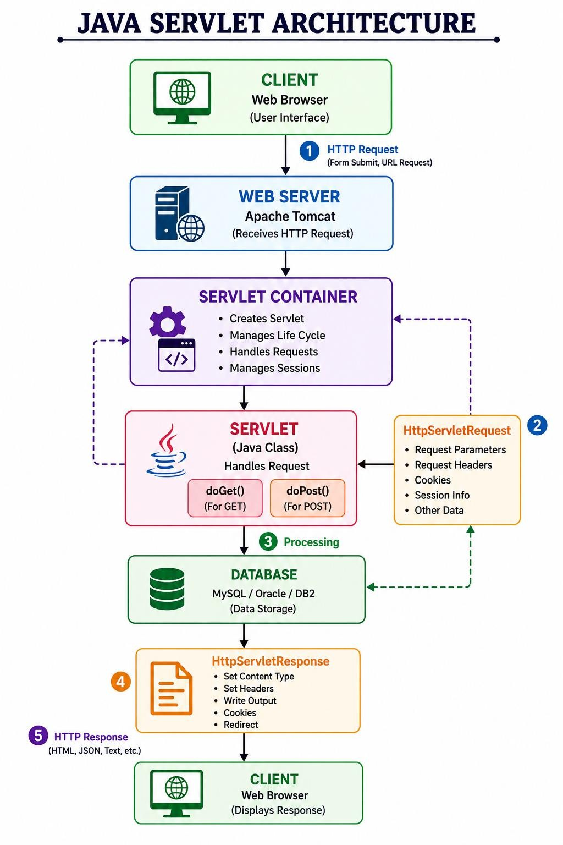

Request–Response Cycle
- User enters information in a web browser.
- Browser sends an HTTP request to the web server.
- The web server passes the request to the Servlet Container.
- The container identifies the required servlet.
- It creates HttpServletRequest and HttpServletResponse objects.
- The servlet processes the request.
- The servlet may communicate with a database or other services.
- The servlet generates a response.
- The container sends the HTTP response back to the browser.
- Browser displays the result.

Request Object
HttpServletRequest contains information sent by the client.
Example:
String name = request.getParameter("name");
It can obtain:
- Form parameters
- Request method
- Headers
- Cookies
- Session information

Response Object
HttpServletResponse is used to send data back to the client.
Example:
response.setContentType("text/html");

PrintWriter out = response.getWriter();

out.println("<h1>Welcome!</h1>");
Simple Workflow
Client
↓
HTTP Request
↓
Web Container
↓
Servlet
↓
Business Logic
↓
Database
↓
Servlet
↓
HTTP Response
↓
Client

2. Servlet Life Cycle Analysis Question:
Explain the Servlet Life Cycle with a sequence diagram and analyze the role of init(), service(), and destroy() methods.
Focus Areas:
- Life cycle phases
- Execution flow
- Performance implications

Answer:

Servlet Life Cycle Analysis
The Servlet Life Cycle describes how a servlet is created, used, and destroyed by the servlet container.

Life Cycle Diagram
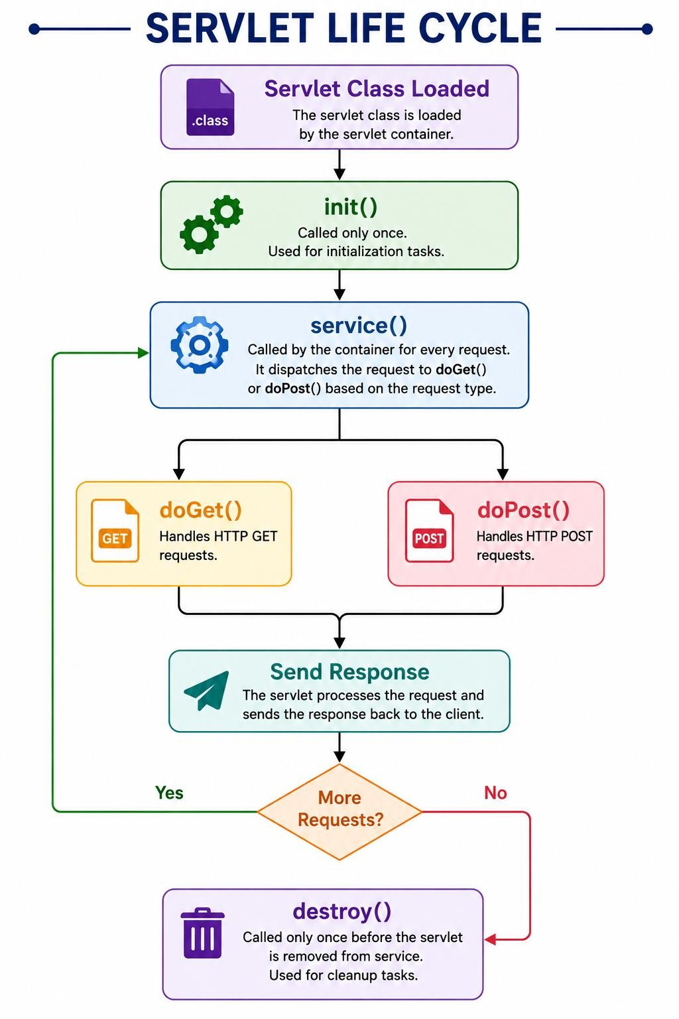

init()
The init() method is called once when the servlet is initialized.
public void init() {
System.out.println("Servlet initialized");
}

Uses
- Initialize resources
- Read configuration
- Establish required initial resources service()
The service() method is called whenever the servlet receives a request.
For HttpServlet, it dispatches the request to methods such as:
GET → doGet() POST → doPost()
Example:
protected void doGet(HttpServletRequest request,
HttpServletResponse response) {
// Process GET request
} protected void doPost(HttpServletRequest request,
HttpServletResponse response) {
// Process POST request

} destroy()
The destroy() method is called once before the servlet is removed from service.
public void destroy() {
System.out.println("Servlet destroyed");
}

Uses
- Release resources
- Close connections
- Perform cleanup

Performance Implications
Method Frequency Performance init() Once Expensive initialization can be done here service() Every request Should be efficient destroy() Once Used for cleanup
Important: A servlet instance can handle multiple requests, potentially concurrently. Therefore, shared mutable instance variables should be handled carefully.

3. GET vs POST Method Evaluation Question:
Compare GET and POST methods used in form submission. Present scenarios where each method is appropriate.
Focus Areas:
- Data transmission
- Security aspects
- URL limitations

Answer:

GET vs POST Method Evaluation
Both GET and POST are HTTP methods commonly handled by servlets.

GET
GET sends parameters as part of the URL.
Example:

Servlet:
protected void doGet(HttpServletRequest request, HttpServletResponse response)
throws ServletException, IOException {

String name = request.getParameter("name");

response.getWriter().println(
"Welcome " + name
);
}

Suitable Uses
- Searching
- Filtering
- Retrieving information
- Pages that can be bookmarked
- Read-only operations Example:
/products?category=mobile

POST
POST sends data in the HTTP request body.
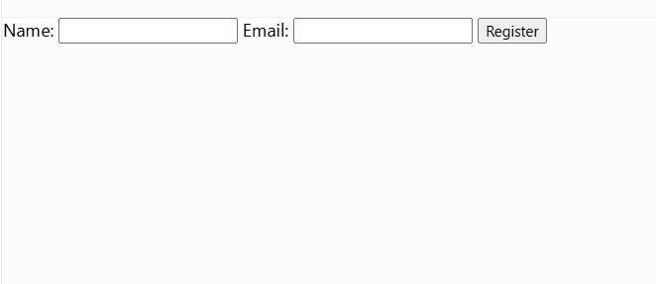
Servlet:
protected void doPost(HttpServletRequest request, HttpServletResponse response)
throws ServletException, IOException {

String name = request.getParameter("name");
String email = request.getParameter("email");

response.getWriter().println(
"Registration successful"
);
}

Suitable Uses
- Registration
- Login
- Payment/order submission
- Updating information
- Uploading data

GET vs POST Table

Feature GET | POST
Data location URL/query string | Request body
Visibility Visible in URL | Not normally visible in URL
Bookmarking Possible | Generally not used for bookmarking
Caching Can be cached | Generally not treated as a simple cacheable retrieval
Limited by URL/request-line
Data size Supports larger request bodies
limits
Idempotency Intended for safe retrieval Often used for state-changing operations
Sensitive data Not appropriate More appropriate, but HTTPS is still required Typical use Search/retrieve Submit/create/update

Security Point
POST is preferable to GET for passwords and other sensitive form data because the data is not placed in the URL. However, POST does not encrypt the data. HTTPS/TLS is required for confidentiality.

4. Session Tracking Techniques Question:
Present different session tracking mechanisms (HttpSession, Cookies, URL rewriting).
Evaluate their advantages and limitations.
Focus Areas:
- Session persistence
- Security concerns
- Use-case comparison

Answer:

Session Tracking Techniques
HTTP is stateless, so a web application needs session tracking to recognize the same user across multiple requests.
The major techniques are:
- HttpSession
- Cookies
- URL Rewriting

A. HttpSession
HttpSession stores session-related information on the server.

Example
HttpSession session = request.getSession();

session.setAttribute("username", "Sravanthi");
Retrieve it:
HttpSession session =
request.getSession(false);

String username =
(String) session.getAttribute("username");
Logout:
session.invalidate();

Advantages
- Convenient API
- Session data is maintained server-side
- Good for login/authentication state
- Can store multiple attributes Limitations
- Uses server memory/storage
- Requires session management infrastructure
- Session IDs must be protected

B. Cookies
Cookies are small pieces of data stored by the browser.
Create Cookie
Cookie cookie =
new Cookie("username", "Sravanthi");

cookie.setMaxAge(3600);

response.addCookie(cookie);
Read Cookie
Cookie[] cookies =
request.getCookies();

if (cookies != null) {

for (Cookie c : cookies) {

if (c.getName().equals("username")) {

System.out.println(c.getValue());
}
}
}

Advantages
- Simple
- Can persist beyond a single session
- Useful for preferences and small client-side values

Limitations
- Stored on the client
- Users can delete or modify them
- Limited storage
- Should not contain sensitive information directly

C. URL Rewriting
URL rewriting adds the session identifier to the URL when cookies cannot be used.
Example:
https://example.com/profile;jsessionid=ABC123
Servlet example:
String url =
response.encodeURL("profile");

out.println("<a href='" + url + "'>Profile</a>");

Advantages
- Works when cookies are disabled
- Useful as a fallback session-tracking mechanism

Limitations
- Session ID can appear in URLs
- URLs may be logged or shared
- Less convenient
- Requires links to be encoded properly

Session Tracking Comparison
Technique | Storage | Advantage Limitation
HttpSession | Server | Good for login/session  Uses server resources data
Cookies | Client | Simple and persistent Can be modified/deleted
URL  Rewriting  Best Choice | URL +  session | server Session ID may leak through  Works without cookies  URLs
For a login system:
HttpSession
+
Secure session cookie
+
HTTPS
is generally the preferred approach

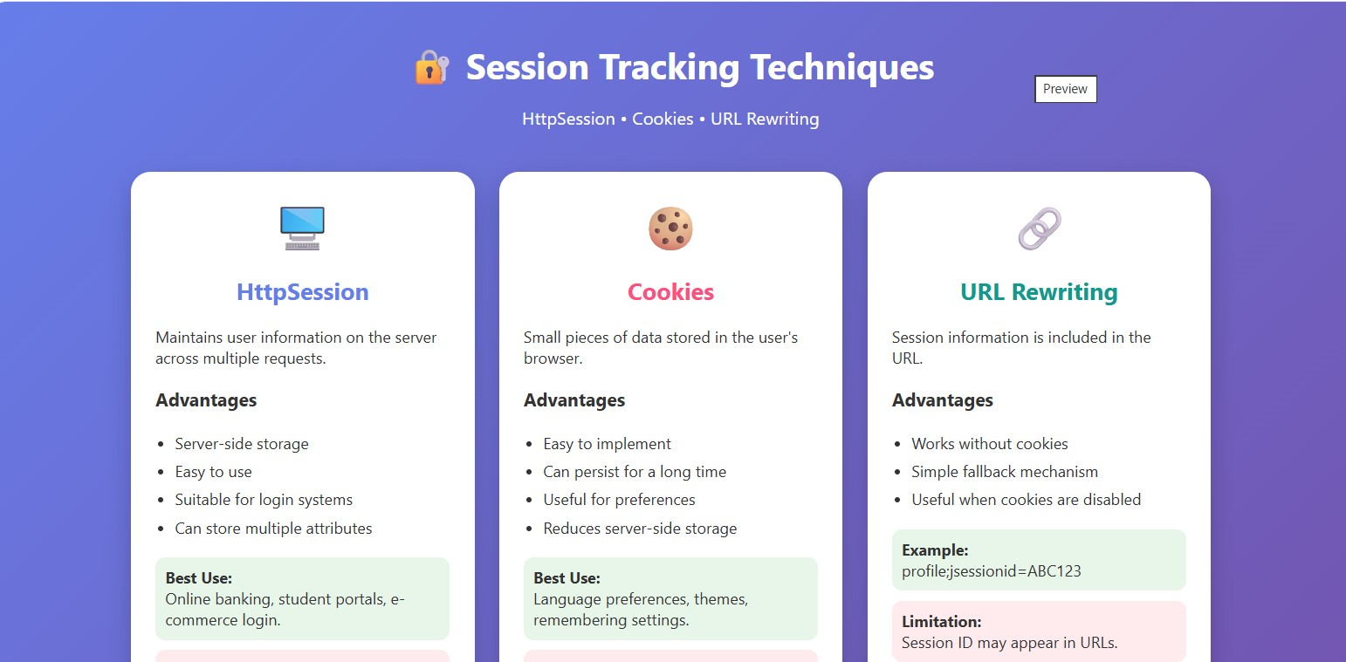
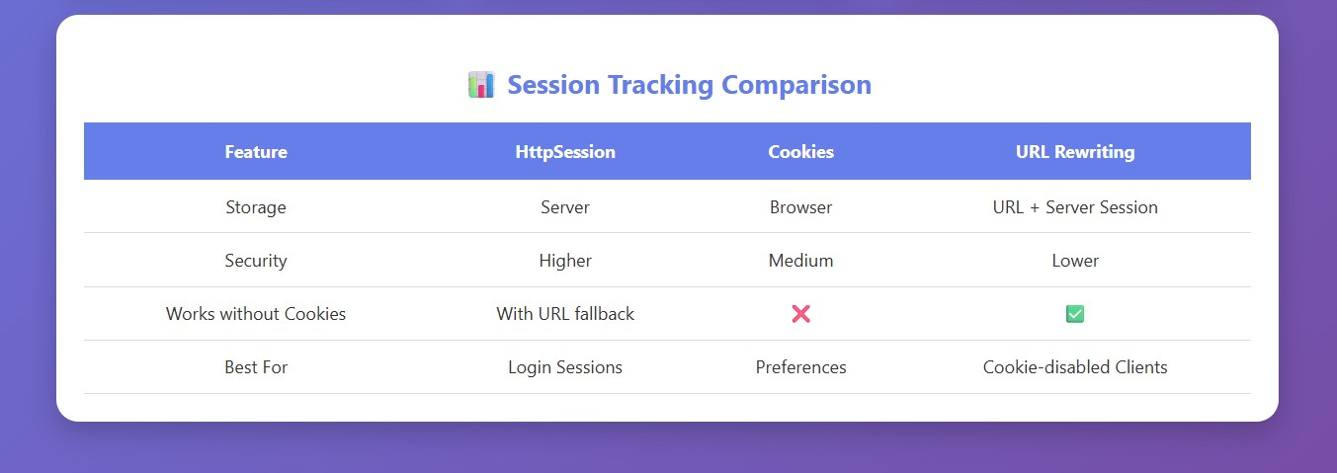

5. Cookies vs Sessions – Critical Analysis Question:
Analyze and compare Cookies and Sessions in web applications. Present real-time use cases. Focus Areas:
- Storage location
- Security risks
- Performance considerations

Answer:
Cookies vs Sessions – Critical Analysis

Cookies
A cookie is stored in the user's browser.
Browser
│
│
▼
Cookie Web Server
Example:
Cookie cookie =
new Cookie("theme", "dark");

response.addCookie(cookie);

Sessions
A session stores the user's application state primarily on the server.
Browser
│
│ Session ID
▼
Server
│
▼
Session Data
Example:
HttpSession session =
request.getSession();

session.setAttribute( "username", "Sravanthi"
);
Cookies vs Sessions
Feature Cookies | Sessions
Storage Client/browser | Mainly server
Identification Cookie value | Session ID
Size Small | Depends on server resources
Usually expires after
Persistence Can persist for a specified time
timeout/invalidation

Feature Cookies Sessions
Security Client can inspect/modify values Data is server-side
Server
Low Uses server resources memory
Avoids server-side storage for simple
Performance Requires server-side session lookup
values
Best use Preferences, non-sensitive identifiers Login/authentication and user state

Real-Time Use Cases

1. Online Shopping
Cookies can remember:
Language = English Theme = Dark
A session can maintain:
Logged-in user
Shopping cart
Checkout state

2. Banking Website
Session management can maintain:
Authenticated user
Current login session
Authorization state
Sensitive information should not simply be stored in client-side cookies.

3. Social Media
A session can maintain the user's authenticated state across:
Home
↓
Profile
↓
Messages
↓
Settings

4. E-Commerce Preferences
Cookies can remember:
Preferred language
Recently selected preferences Security Considerations
For authentication sessions, applications should use secure cookie attributes such as:

Secure
HttpOnly
SameSite

Secure
Cookie is sent only over HTTPS.
HttpOnly
Helps prevent JavaScript from directly reading the cookie.

SameSite
Helps reduce certain cross-site request risks.
Also:
- Use HTTPS.
- Do not store passwords in cookies.
- Use sufficiently strong, unpredictable session IDs.
- Invalidate sessions during logout.
- Regenerate the session ID after authentication where appropriate.
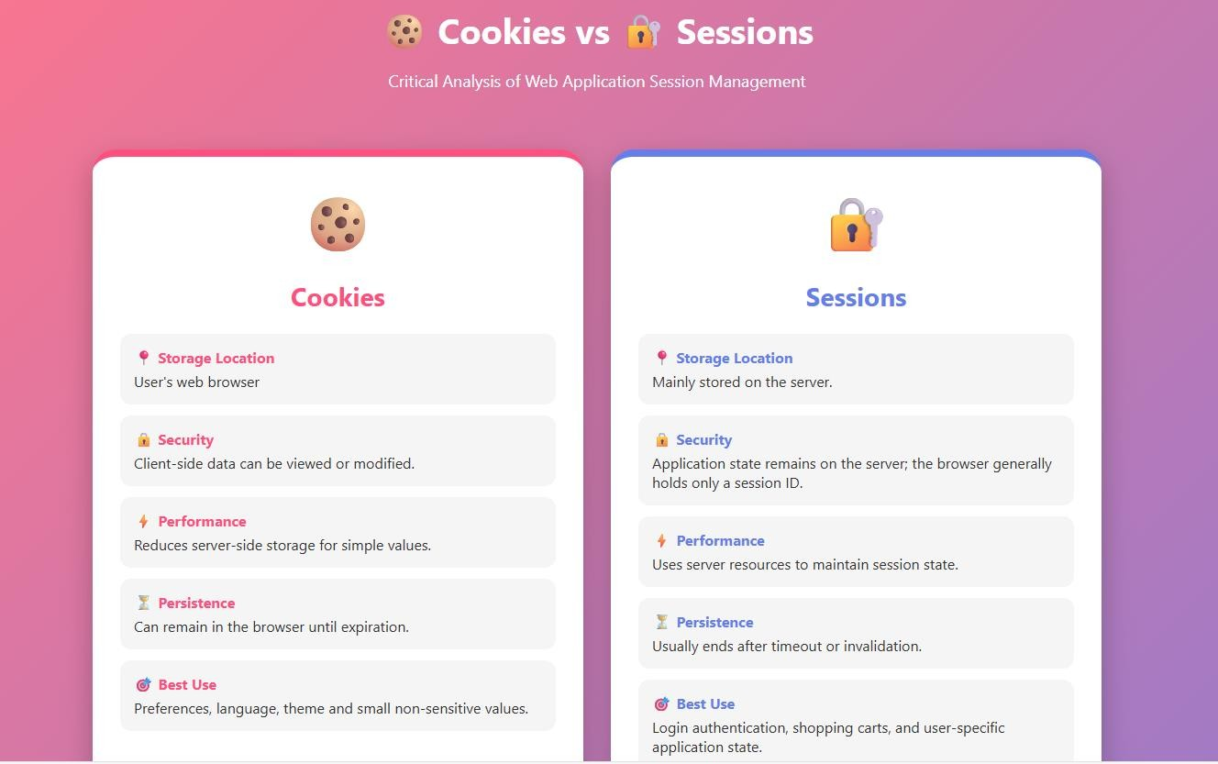
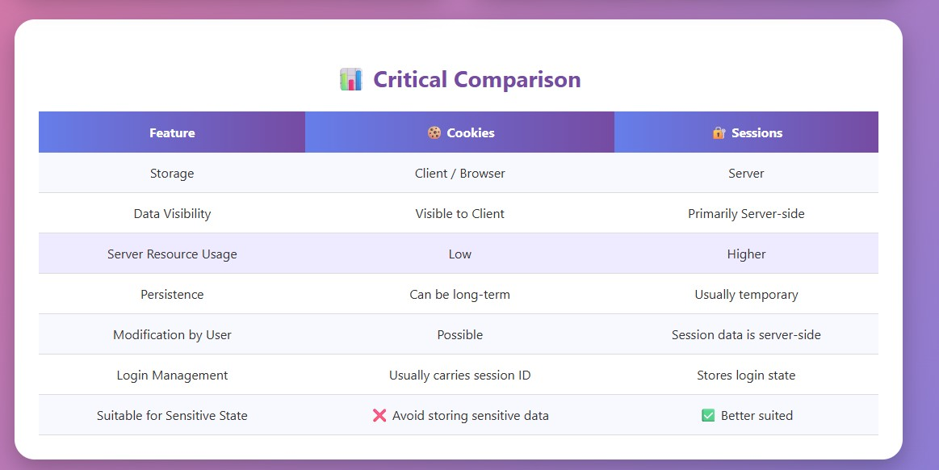

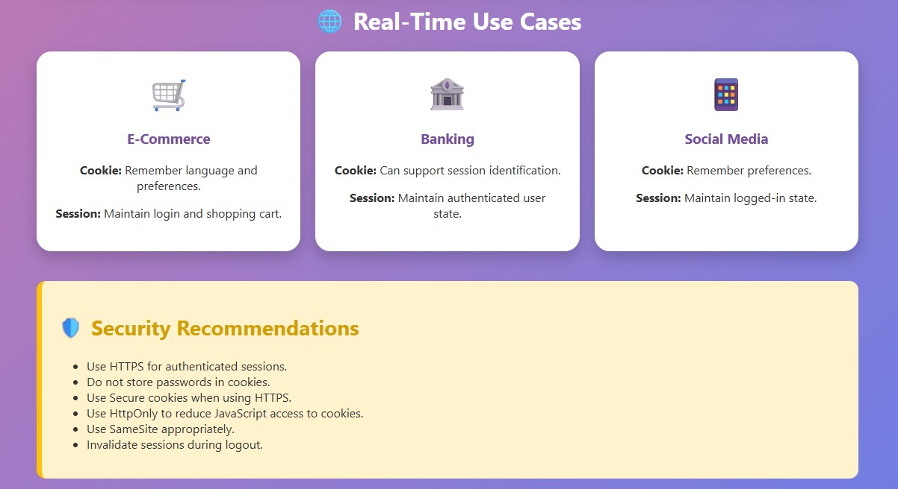

Code of Conduct:

I (U. Ushasree / 192372360) certify that this submission is my original work and that I have adhered to the guidelines specified for this assessment. I understand that any violation of academic integrity rules will result in disciplinary action.

Signature of the student: U. Ushasree

RUBRICS FOR CALCULATION:

Technical Presentation
Criteria | Weight age | Level 4 Exemplary | – | Level 3 –  Proficient | Level 2 –  Developing | Level 1 Beginning | –
Technical  Content  Accuracy | 30 | Highly accurate, indepth, and  insightful technical explanation |  | Technically correct content with adequate  depth and  clarity | Basic concepts presented with limited  accuracy and  depth | Content contains major technical errors; concepts poorly understood
Problem  Identification | 25 | Problem rigorously analyzed using appropriate and advanced methods |  | Problem clearly defined with a logical  engineering approach | Problem  identified but analysis or methodology is weak | Problem  statement  unclear or incorrect; no  logical approach
Use of Tools | 20 | Advanced tools, wellanalyzed data, and highly  effective visuals |  | Appropriate tools and data used  effectively  with clear  visuals | Limited use of tools and basic data interpretation | Minimal or incorrect use of tools and data; poor  visuals
Communicati on | 15 | Highly engaging, confident, and audiencefocused delivery |  | Clear, organized, and professional communicati on | Understandabl e but lacks  clarity,  structure, or confidence | Poor organization, unclear speech, ineffective slides
Professionalis m | 10 | Exemplary professionalis m, leadership, and ethical awareness |  | Professional conduct with  effective team collaboration | Basic professionalis  m; uneven  team participation | Lacks professionalis  m; minimal contribution or  ethical awareness

